**Lesson 1 How to setup and compile a station-GRF**

I think we can get started.... :twisted:  
  
First of all, I would like to see if you are able to compile a GRF using the template code and graphics that I have prepared for you. I have made a .rar with everything in it:

**Attachment:**

http://www.simuscape.net/simutalk/styles/twilightBB/imageset/icon_topic_attach.gif[grfcodec603.rar](http://www.simuscape.net/simutalk/download/file.php?id=3266) [1.31 MiB]   
Downloaded 1 time

Save this .rar on the D-partition of your computer (I hope you have a D-partition, if not, just save it on the standard C-partition and let me know, then I will code an NFO-file that has the right path for the graphics-files).  
  
Unpack the .rar to a folder of the same name by rightclicking on it and selecting unpack to folder grfcodec603:

**Attachment:**

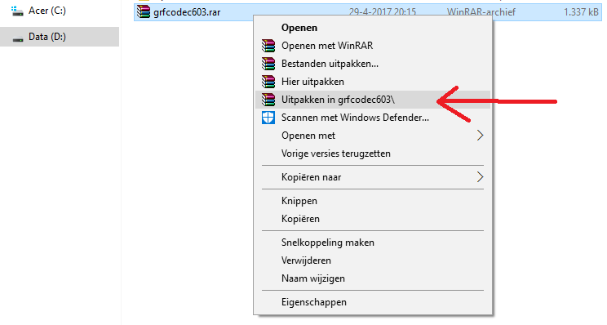  
Example242.png [ 18.05 KiB | Viewed 78 times ]

When unrarred the folderstructure should look something like this:

**Attachment:**

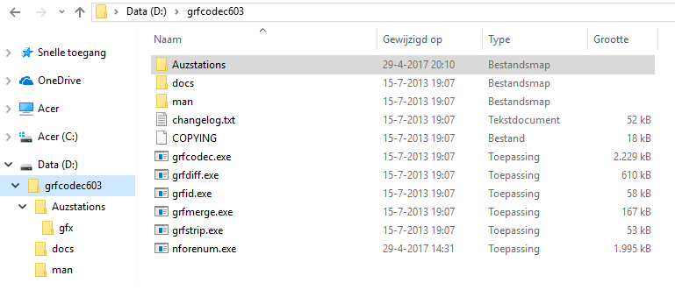  
Example241.png [ 35.96 KiB | Viewed 78 times ]

You now have all the programs, code and graphics you need to make a GRF using NFO-code.  
The main two programs are grfcodec.exe (that will compile the GRF, like NMLC for NML) and nforenum.exe (as you shall see, all the lines of code have a number. Adding those numbers by hand is a pain in the rear, luckily a handy program like this exists ;-))  
In the folder Auzstations you will find the code (auzstations_1_v001.nfo) and in the folder gfx you will find the graphics.  
You can look at the code by opening the .nfo with the standard Windows Notepad (that will also be the program we will use to edit the code).

Last edited by [**Quast65**](http://www.simuscape.net/simutalk/memberlist.php?mode=viewprofile&u=102) on 30 Apr 2017, 06:17, edited 1 time in total.

Right, now if all this is setup correctly you should be able to compile a GRF.  
- Open up a commandprompt (just like with NML compiling)  
- Go to partition-D, by typing

**Code:**

d:

- Go to folder grfcodec603, by typing

**Code:**

cd grfcodec603

- Finally type

**Code:**

grfcodec -e -g 2 d:/grfcodec603/auzstations/auzstations_1_v001.grf d:/grfcodec603/auzstations

Should look something like this then:

**Attachment:**

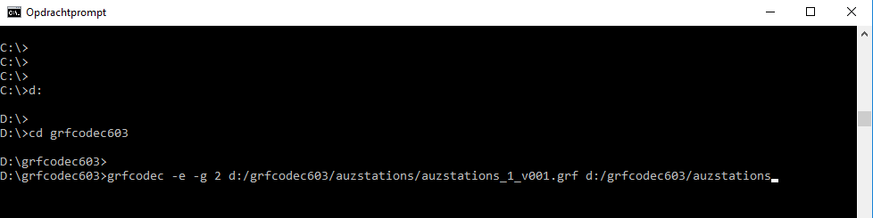  
Zoom in (real dimensions: 978 x 245)Example243.png [ 6.36 KiB | Viewed 78 times ]

And finally press ENTER  
It should then compile and result in a GRF in the auzstations-folder  
Let me know if this all worked (or not :oops:)  
If it did work you should be able to make these stations:

**Attachment:**

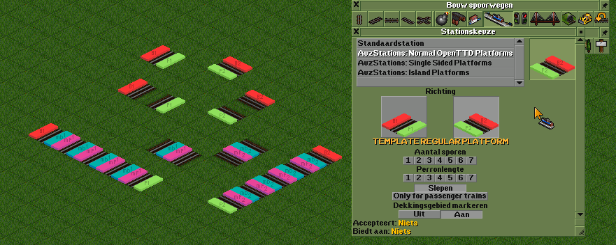  
Zoom in (real dimensions: 881 x 352)  
Example244.png [ 60.27 KiB | Viewed 78 times ]

If it worked I will go on explaining, otherwise I will help you out to see why it wont compile.

**Quote:**

More then happy change the colours of the platforms .. would you like if I use Dos or Windows Palette?

No need to worry about palette colors anymore, it should be coded in a way that you can use all colors of the Rainbow, that gives you more freedom, especially when using textures from photo's ;-)Only thing you need to check is that you dont use unwanted animated colors (the infamous christmaslights :mrgreen:)   
But to check for that, you must be able to compile a GRF, so back to that first ;-)

**Quote:**

EDIT: Forgot to tell you .. I have drives C: E: and F: .. D is the DVD player .. so I will put them on C:

OK, C: it is then. Replace the .nfo with this one:

**Attachment:**

http://www.simuscape.net/simutalk/styles/twilightBB/imageset/icon_topic_attach.gifauzstations_1_v001.nfo [15.81 KiB]   
Downloaded 1 time

We now should have exactly the same setup, so we both have to do the exact same steps to get a GRF, making it easier to check where something may go wrong ;-)  
  
When you have replaced the .nfo you now need to do this:  
  
- Open up a commandprompt (just like with NML compiling)  
- Go to C:, possibly by typing this a couple of times:

**Code:**

cd..

- Go to folder grfcodec603, by typing:

**Code:**

cd grfcodec603

- Finally type:

**Code:**

grfcodec -e -g 2 c:/grfcodec603/auzstations/auzstations_1_v001.grf c:/grfcodec603/auzstations

Should look something like this then:

**Attachment:**

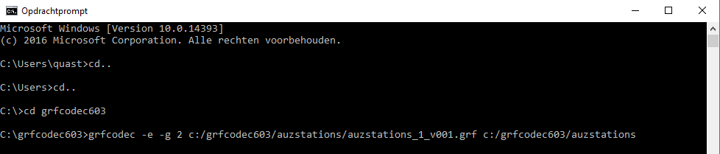  
Zoom in (real dimensions: 978 x 209)Example245.png [ 8.27 KiB | Viewed 76 times ]

And finally press ENTER  
It should then compile and result in a GRF in the auzstations-folder  
  
Let me know if you get a working GRF, if so we can move on to altering the graphics to ones that suit you. Final step will be adding code, but that will be tomorrow for me, getting late overhere ;-)